Ideation Phase

Brainstorm and Idea Prioritization Template

|  |  |
| --- | --- |
| Date | 31 January 2025 |
| Team ID | LTVIP2025TMID53108 |
| Project Name | FlightFinder |
| Maximum Marks | 4 Marks |

**Brainstorm & Idea Prioritization Template:**

**1. Smart Flight Search Engine**

* **MongoDB Atlas Search with autocomplete & fuzzy matching**
* **Search by airport code, city, airline, price, or even vague terms like “cheap Europe flights”**

**2. Dynamic Index Management**

* **Automatically create/destroy indexes based on query patterns**
* **Prioritize compound indexes on high-traffic search combinations**

**3. Aggregated Deal Insights**

* **Use $group, $sort, and $project to find best deals by region or airline**
* **Daily/weekly “hot routes” based on price drops or user interest**

**4. Real-Time Availability & Pricing**

* **Integrate external APIs and optimize update frequency using TTL indexes**
* **Track and cache time-sensitive data intelligently**

**5. Advanced Filters & Alerts**

* **Filter by layovers, travel duration, aircraft type, CO₂ emissions User alerts on price drops or changes on tracked routes**

**6. Multilingual & Localized Search**

* **Store localized metadata and dynamically match based on user region/preferences**

**7. Admin Dashboard for Optimization**

* **Visualize query patterns, slow queries, and index performance**

**Step-1: Team Gathering, Collaboration and Select the Problem Statement**

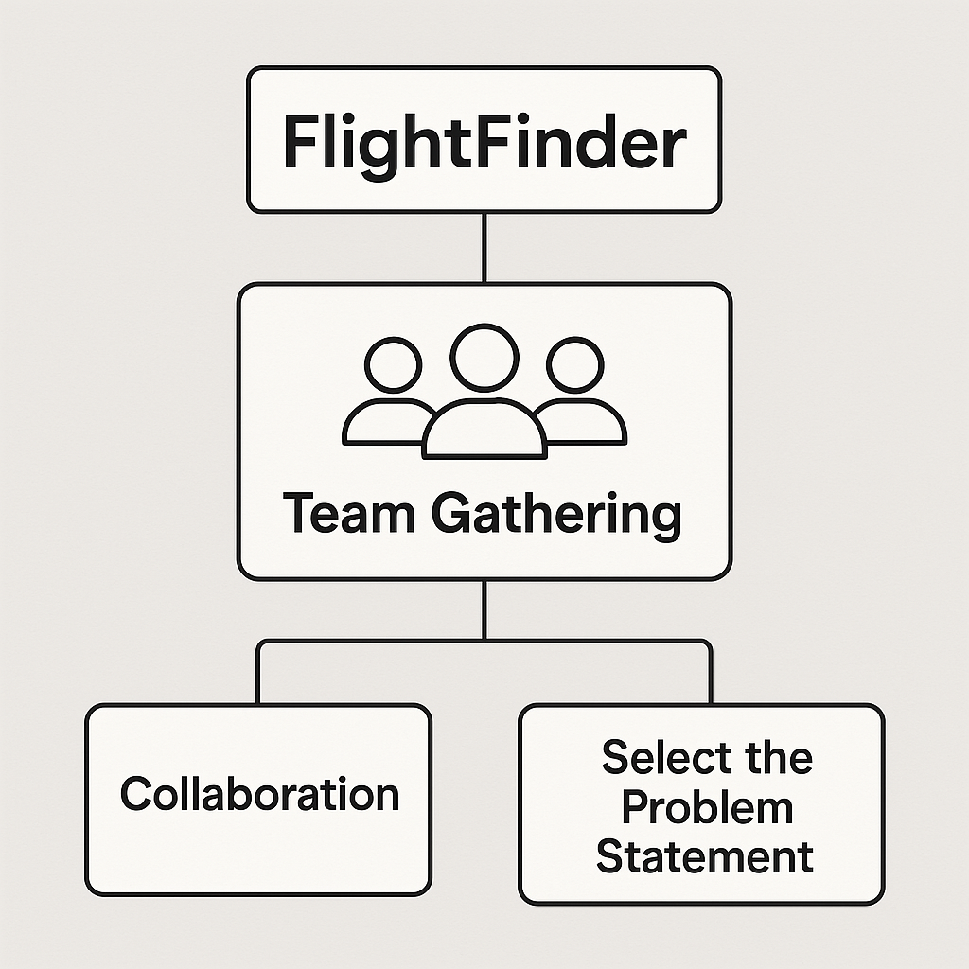

**Step-2: Brainstorm, Idea Listing and Grouping**

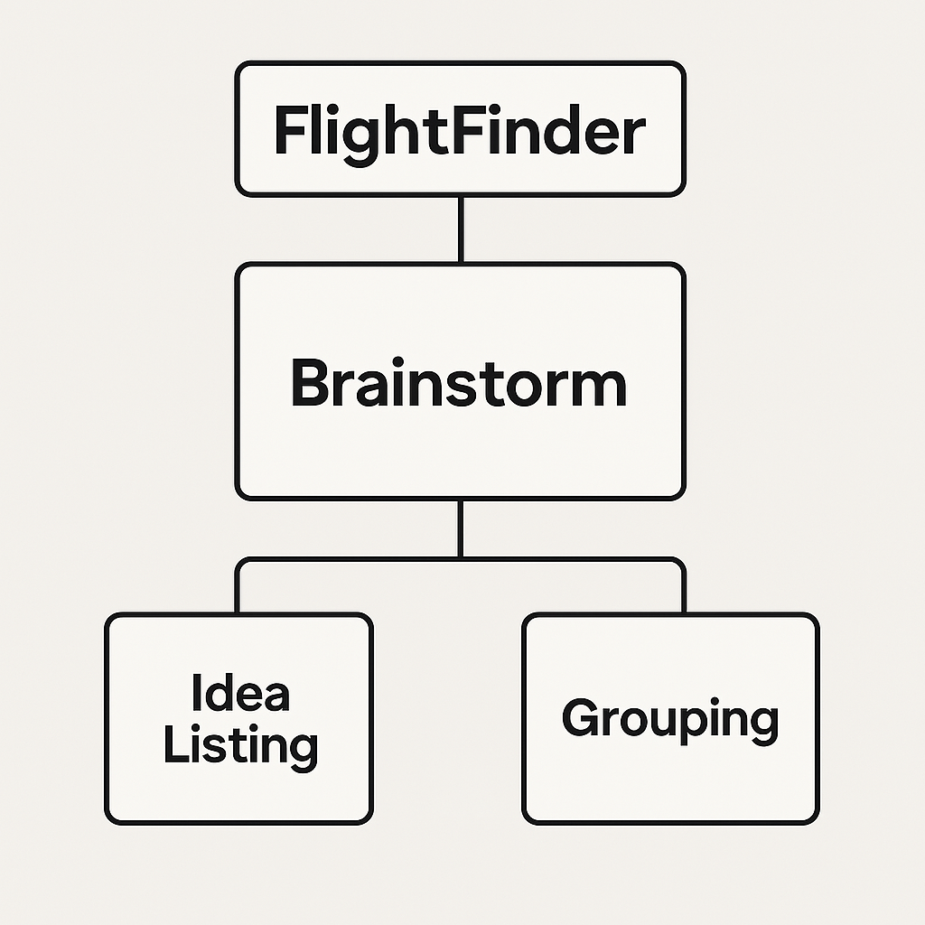

**Step-3: Idea Prioritization**

